**UNIVERSITY OF MAKENI**

**(Sylvannus Koroma Campus)**



**WEB PROGRAMMING 2**

**Lecturer: Mr Abdulai Brato Kamara**

**Topic: Misinformation Solver**

**Dominic Oladapo-Tonade 6469**

**Mabel F. Jimissa 6714**

**1. INTRODUCTION**

Misinformation is a major problem in this modern, connected generation. Although various forms of propaganda have been around for ages, digital ‘fake news’ is no longer becoming but now a major threat, partly due to the ease of creating, releasing and digesting contents.

Speech and Action are not left out in the fight against misinformation. Misinformation can be spread through various forms of speech, including verbal communication, written content, social media posts, videos, and more. People may intentionally or unintentionally share false or misleading information, leading to its propagation. Speech-related activities, such as sharing misleading news articles, creating false narratives, or spreading rumors, contribute to the dissemination of misinformation.

Taking action is the effort aimed at countering misinformation and its negative impact and it involves implementing strategies and initiatives to address misinformation and promote accurate information. Actions can include fact-checking, debunking false claims, promoting critical thinking skills, educating the public about reliable sources, engaging in media literacy programs, fostering digital literacy, and encouraging responsible information sharing practices.

**2. AIMS AND OBJECTIVES**

Misinformation Solver, our mission is to combat the spread of misinformation and promote accurate information in an increasingly complex digital world. We understand the significant impact that misinformation can have on individuals, communities, and society as a whole and that's why we are dedicated to providing reliable resources, debunking myths, and fostering critical thinking. Our team of experienced researchers and fact-checkers works diligently to separate fact from fiction, employing rigorous methodologies to ensure the information we present is accurate and up-to-date. We believe in the power of evidence-based information and strive to empower our users to make informed decisions.

**3. IMPLEMENTATION**

* Technologies Used
* Programming Languages
* Python
* HTML
* JAVASCRIPT
* CSS
* Framework – Django framework
* Frontend – HTML & CSS
* Backend – Python, JavaScript
* Setting up the Development Environment

To set up the development environment for the Misinformation Solver, the following steps were taken:

**Install Python:** Download and install the latest version of Python from the official Python website ([www.python.org](http://www.python.org))

**Create folder:** Create a project folder in your documents directory.

**Install / update ‘pip’:** Install ‘pip’ using the command ‘python -m install pip’

**Install ‘virtualenv’:** Install ‘virtualenv’ using the command ‘pip install virtualenv’

**Start ‘virtualenv’:** start the virtual environment using the command ‘virtualenv venv’

**Install Django:** Run ‘pip install Django’ to install Django.

**Create a new Django project:** Run ‘Django-admin startproject <projectname>’ to create a new Django project.

**Create a new Django app:** Navigate into the project directory using cd <projectname> and run ‘python manage.py startapp <appname>’ to create a new Django app within the project.

**Configure the project:** Open the settings.py file in the project directory and modify the necessary settings, including database configurations and static/media file paths.

**Run the development server:** Execute ‘python manage.py runserver’ in the command prompt/terminal to start the development server.

**5. Experimental Result**

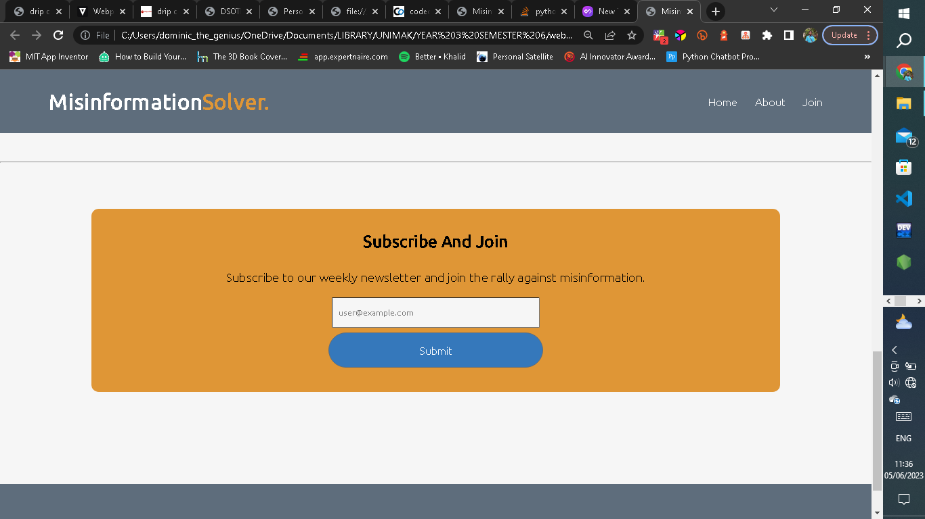

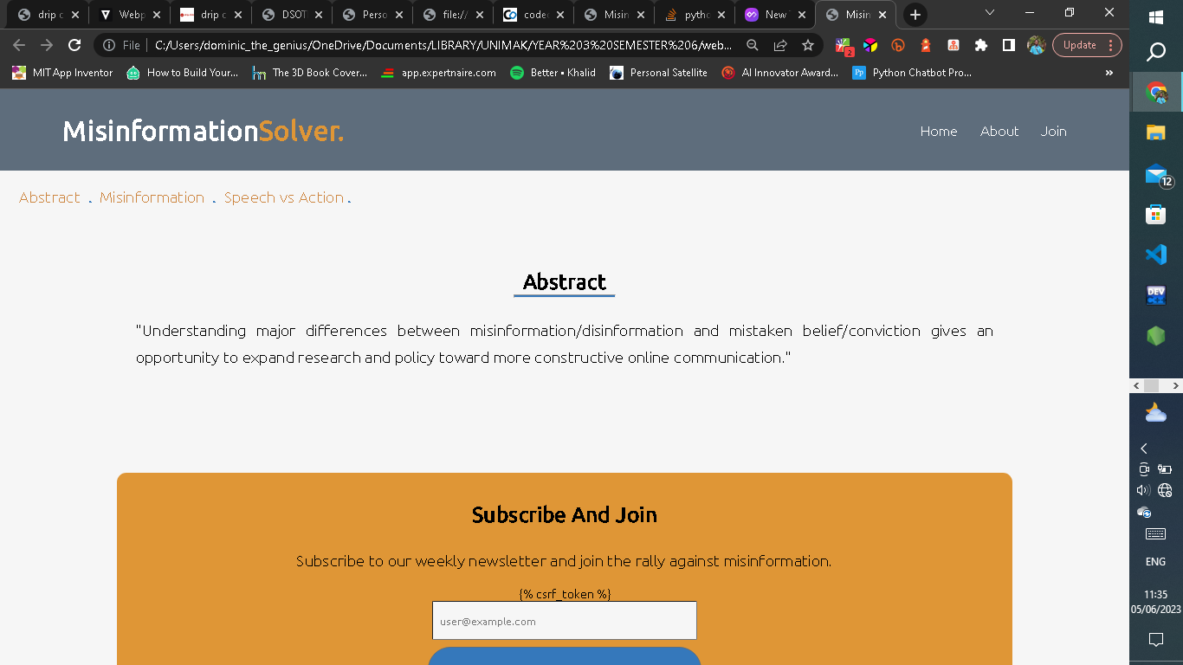

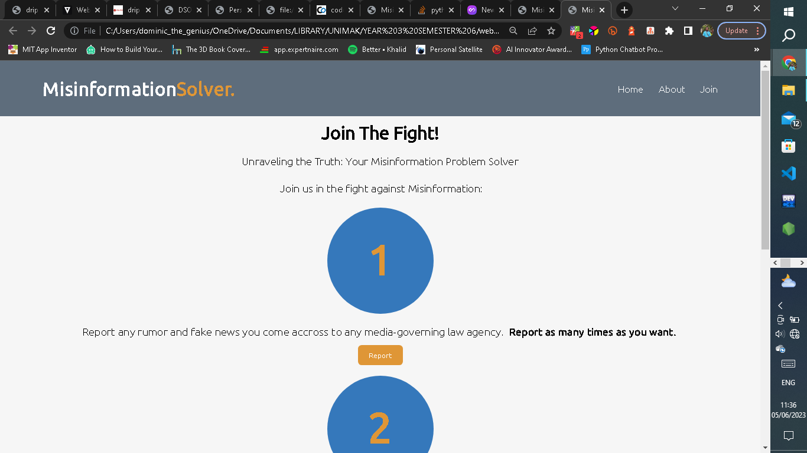

**6. Conclusion**

The misinformation solver web app is designed mainly to, in attempt to eradicate, supress the level of misinformation in local communities and the world at large.

This study / research is based on incidents from different parts of the world during the years 2021-2023.

References are given to the following organizations / sites for the research and the development of the web app:

* Science Advances – How do you solve a problem like misinformation ([www.science.org](http://www.science.org))
* Innovation Mode – Fake News and Misinformation using digital technologies ([www.theinnovation.com](http://www.theinnovation.com))
* [www.codeopinion.com](http://www.codeopinion.com)
* [www.stackoverflow.com](http://www.stackoverflow.com)